NAME: P VINEETHA
REG: 192373053
COURSE: DAA CSA0603

1: First Palindromic String in an Array and find its completity
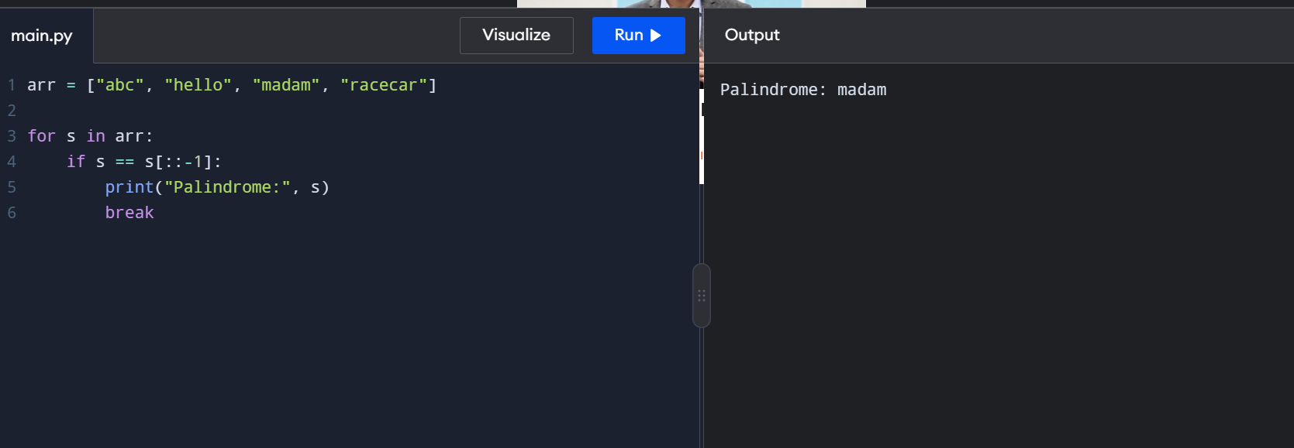
Time: O(n × m)
Space: O(m)
2: Common Elements Between Two Arrays and find its completity
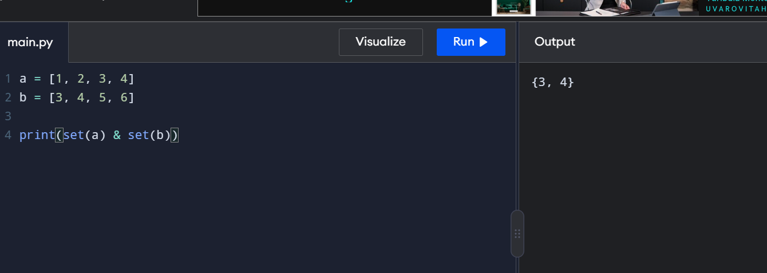
Time: O(n + m)
Space: O(n + m)

3: Subarrays Distinct Element Sum of Squares
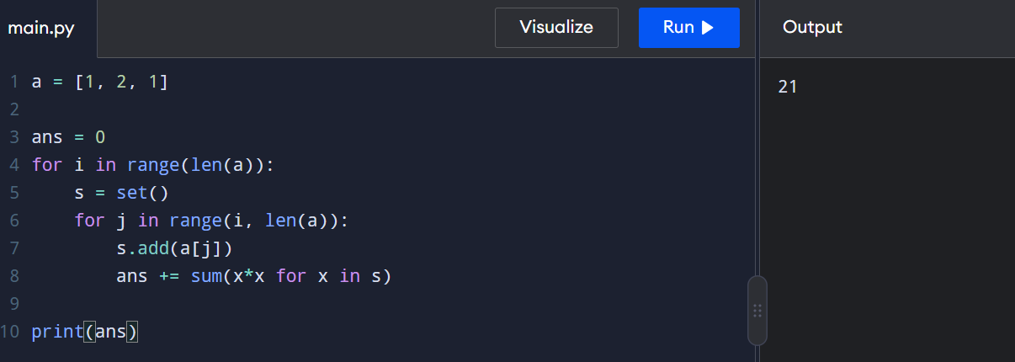
Time: O(n³)
Space: O(n)
4: Count Equal and Divisible Pairs in an Array
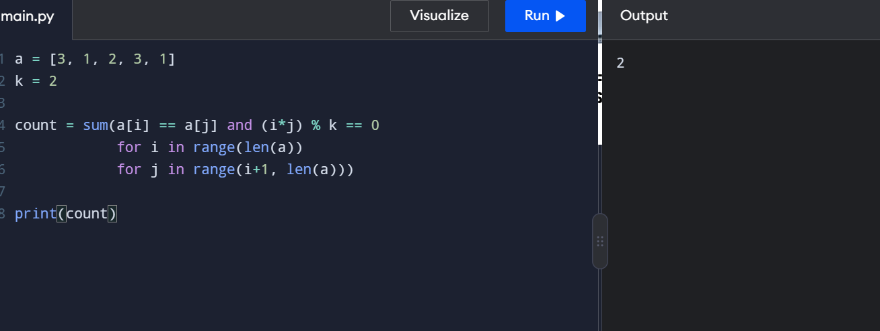
Time: O(n²)
Space: O(1)
5: Maximum Element with Least Time Complexity
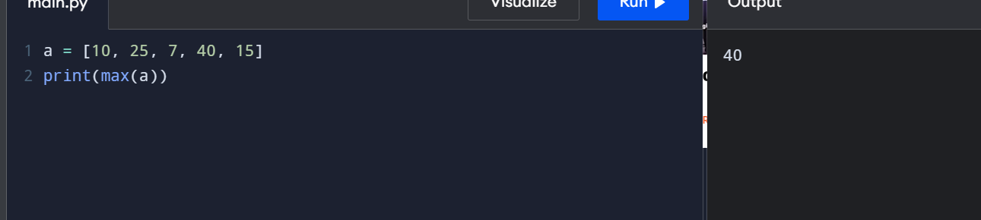
Time: O(n)
Space: O(1)

